Food Crop Production: Linear Trend & Projection
Problem Statement
U.S. food-crop (produce) output faces long-term pressure from land-use change, climate, and economics. Using state-level production data (1998–2012) we ask: Is there a clear linear decline in average total production, and what does a simple extrapolation imply for the coming decades?
Solution Strategy
1. Aggregate panel to yearly mean totalprod. 2. Fit OLS (sklearn + polyfit + closed-form verification). 3. Project to 2050. 4. Stress-test with noise Monte-Carlo, year-window, and bootstrap CI. 5. Adapt narrative for analysts, executives, agronomists, and the public.
Solution
Slope ≈ −24 300 units/year (R² ≈ 0.96). The fitted line crosses zero around 2029. Yield per acre also declines while price per pound rises. Bootstrap intervals are wide — the linear extrapolation is a risk signal, not a precise forecast.
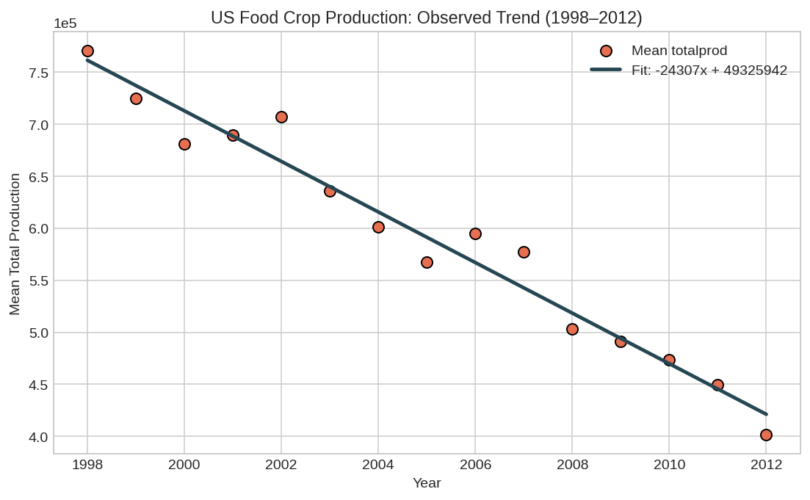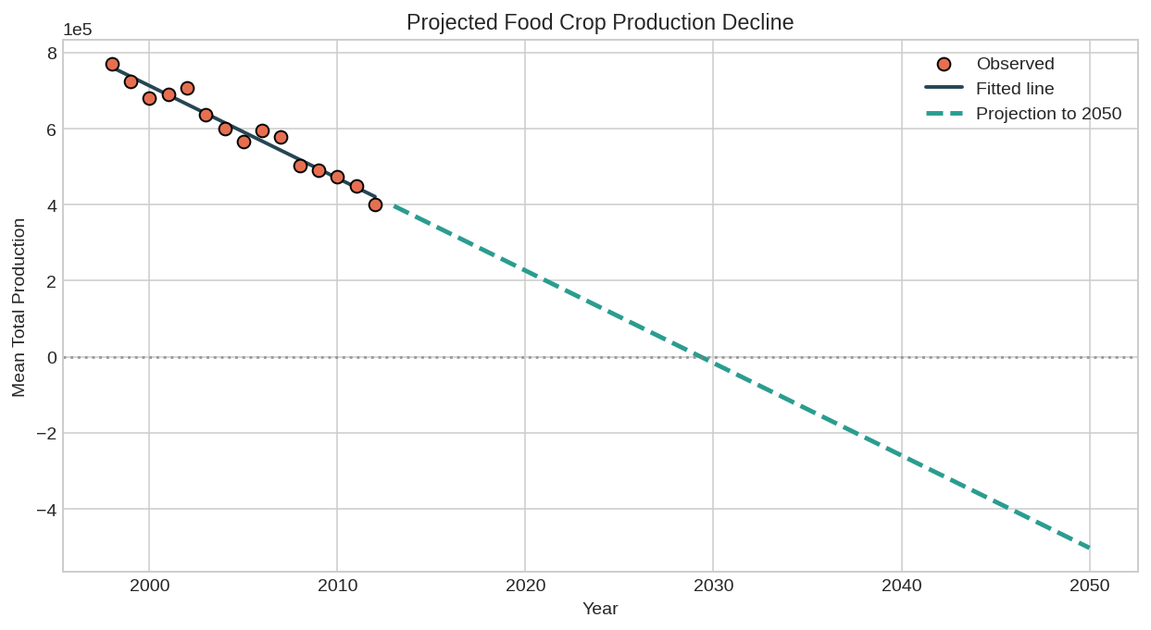
Left: observed + OLS fit. Right: projection (crosses zero ~2029).
Key Takeaways
• Average state food-crop production fell ~24 k units each year; the linear trend is strong (R² ≈ 0.96).
• Naïve extrapolation reaches zero around 2029 — a stark warning for food-system planning.
• Yield trends down and prices up, consistent with scarcity pressure.
• Always report uncertainty (bootstrap) and adapt depth to the audience.

